**12-19 notes**

JavaScript with D3.js

Goals:

* Create charts by using data from API calls.
* Use D3 for basic document object model (DOM) manipulation and event handling.
* Apply the this keyword to reference elements within a function.
* Dynamically manipulate the DOM through events.
* Manipulate charts through dropdown events and click events.
* Use Plotly.restyle() to create dynamic charts.

During Class objectives slide. 6:38-6:50pm in recording.

D3 is a document object mark, like BeautifulSoup. It loads the whole page of html.

Event listeners listen for an event to happen.

This- which particular button has been selected.

* References elements within a function

D3 is mostly used for updating charts via dropdown and click events.

* Also possible within Tableau, but we gotta learn the hard way first.

There’s a lot of restyling that you can do, not just what we cover in the last activity of today.

**D3.js is an incredibly powerful visualization library written in JavaScript. Data professionals use it to create interactive data visualizations in browsers.**

D3 stands for Data-Driven Documents

You don’t need to download the whole D3 library to use it. Just make sure that the following code is included in the body of the HTML page:



Promise pending in JS makes sure the URL is up and running. It promises to get the data even if it’ll take a while. If it’s gonna fail, it’ll fail pretty quickly. If you don’t get an error message, it means it’s still trying to get the data

**Instructor intro Demo solution:**

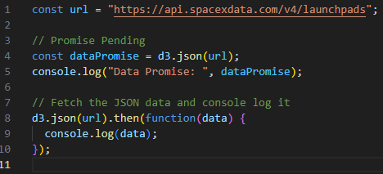

**7pm-ish in recording- What is a constant when using D3?**

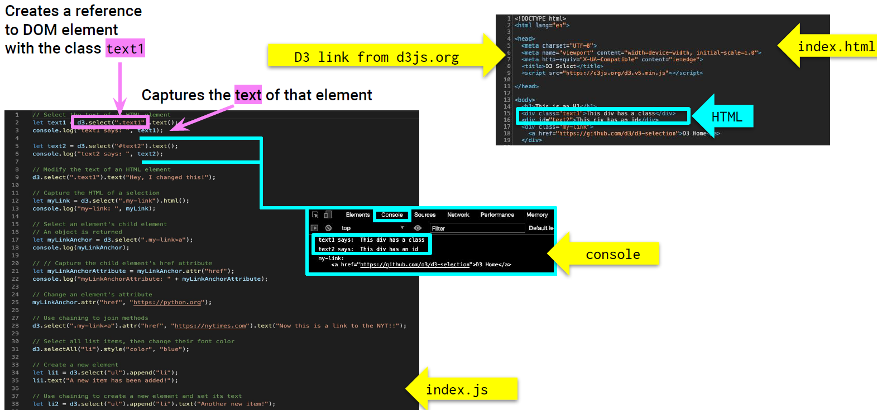

^ screenshot of Module 14.3 slide 10

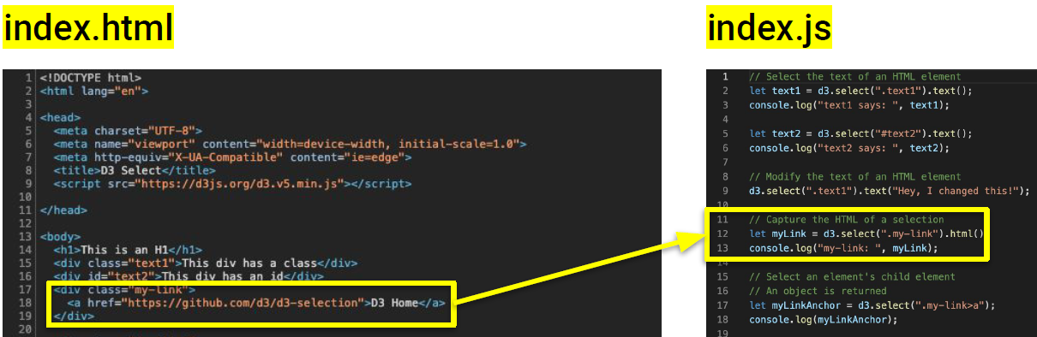

^ D3 allows you to traverse through the html code to copy it, remove it, or add data.

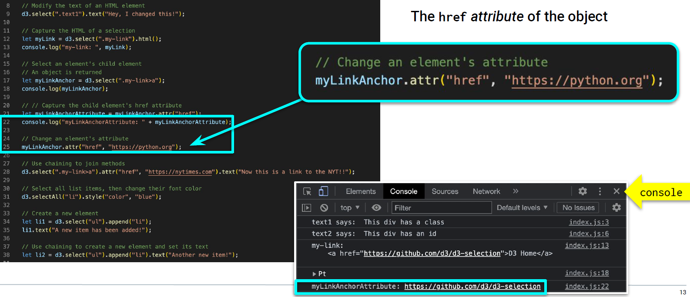

**Ins D3 Select Solution:**

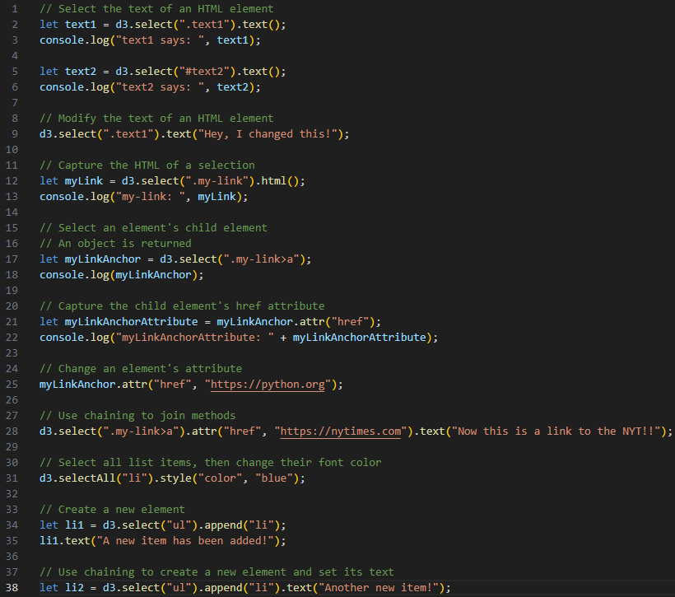

^ line 2 uses .text1 because in the HTML text1 is a class (see below)

^ line 5 uses #text2 because in the HTML text2 is an ID (see below)

^ line 25 changes the url for the first hyperlink to go to python.org, while keeping it showing ‘D3 Home’

^ line 28 changes the url AND the text for the first hyperlink on the page.

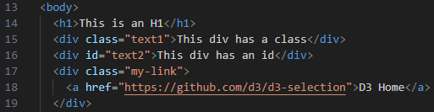

^ line 9 changes the text in the browser, not logging it in the console.

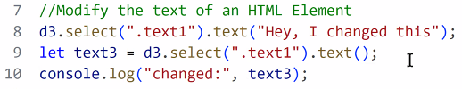

^ even with putting a new console.log(“changed: ” : text1) doesn’t show it in the console.

**Everyone D3 Select Solution:**

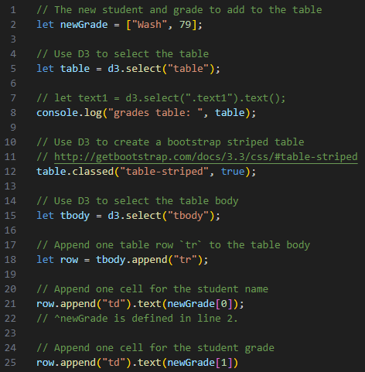

An event is an action triggered by the user or the browser. JavaScript listens for the event to then execute the code (interact with HTML).

There are several event types that are supported by the browser, including:

* click
* change
* keydown
* scroll
* pointenter
* pointerleave

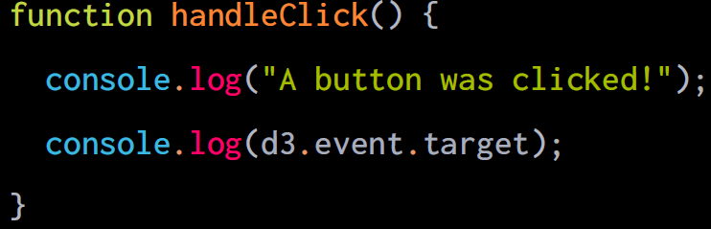

Events have two main components:

* **Target-** Reference to the object that dispatched the event.
* **Handler-** Function that executes in response to the event occurring.

**Instructor Event Listeners Solution:**

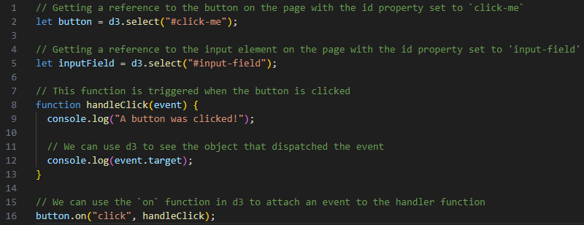

**Review 8:23-8:24pm.**

^ Line 16 attaches the function to the event of the button being clicked (to the ON position)

^ Line 16- You don’t have to call the function outside of the parentheses. You can copy/paste lines 8 and 9 over the yellow text “handleClick” on line 16. (See lines 19-22 below)

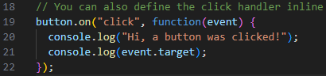

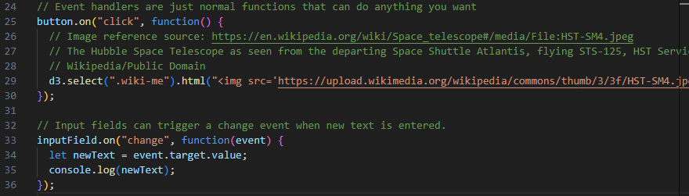

^ Lines 25-30 are making the image show up when you click

^ Lines 33-36 are making the text that is typed show up in the console.

**Student Button Click Solution:**

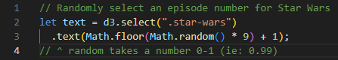

Review 8:37-8:38pm for math for lines 2-3

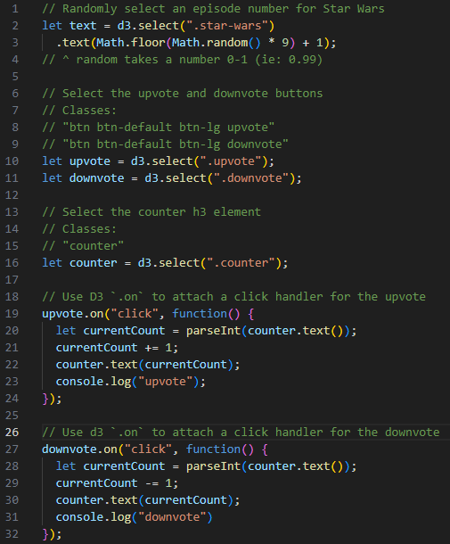

^ Lines 23 and 31 log within the console when 1 or more upvote or downvotes occur.

**This:**

In JavaScript, the this keyword refers to the object it belongs to. It has different values depending

on where it is used.

It can be very resourceful to identify which element triggered an event.

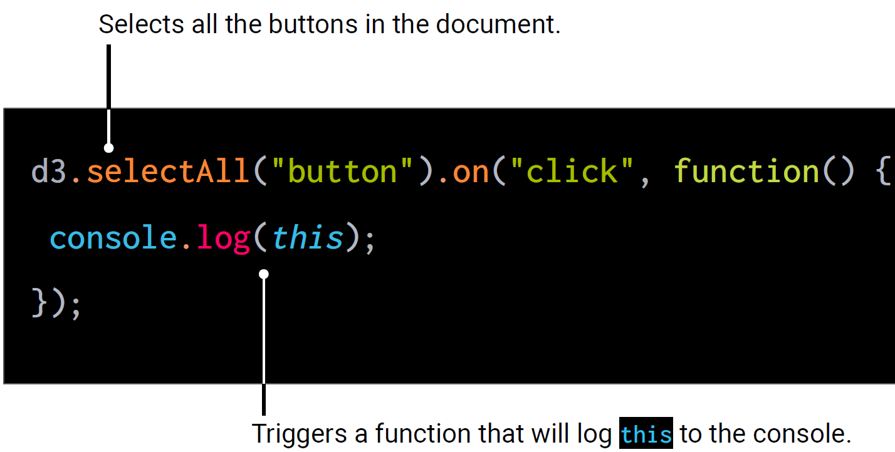

**Instructor This Solution:**

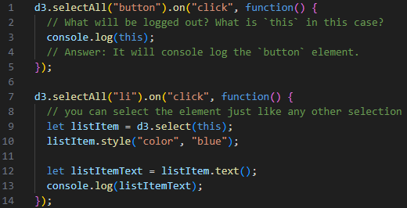

^ This code makes it so that when you click on an item in the list or the buttons at the top it’ll log it in the console.

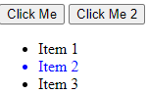



**Everyone This Solution:**

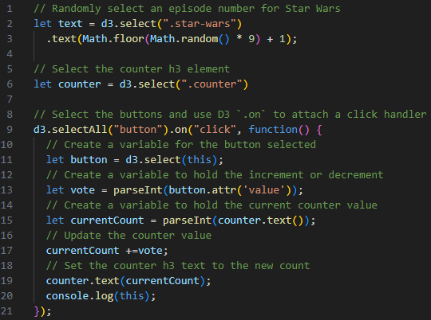

^ Line 9- function() can have the text event in the parentheses or not. Not required.

Hovering over event yields the below text box.

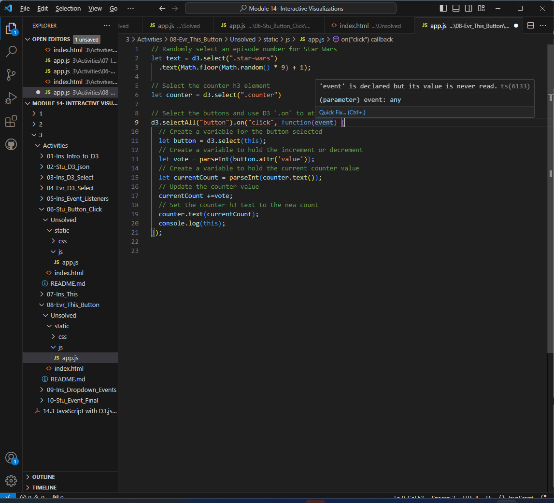

If you have event in the parentheses, you can read it later in the code.

**Review 9:04-9:08pm in recording (Manish describing the pseudocoding)**

**D3 DOM element (Document Object Model)-** Programming interface for web documents. It represents the page so that programs can change the document structure, style, and content. The DOM represents the document as nodes and objects; that way, programming languages can interact with the page.

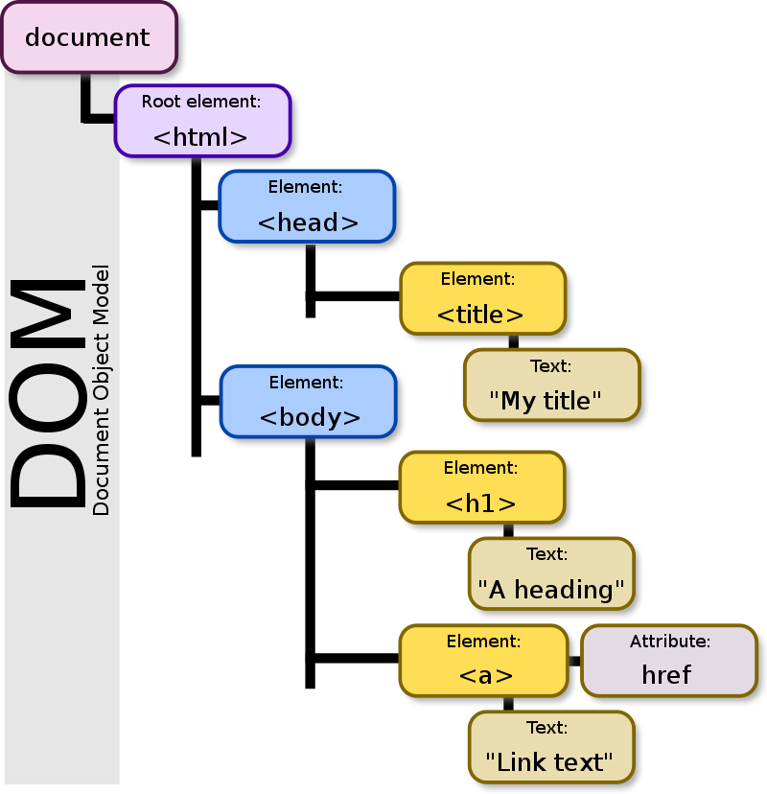

^ Image from <https://en.wikipedia.org/wiki/Document_Object_Model>

**Instructor Dropdown Events Solution:**

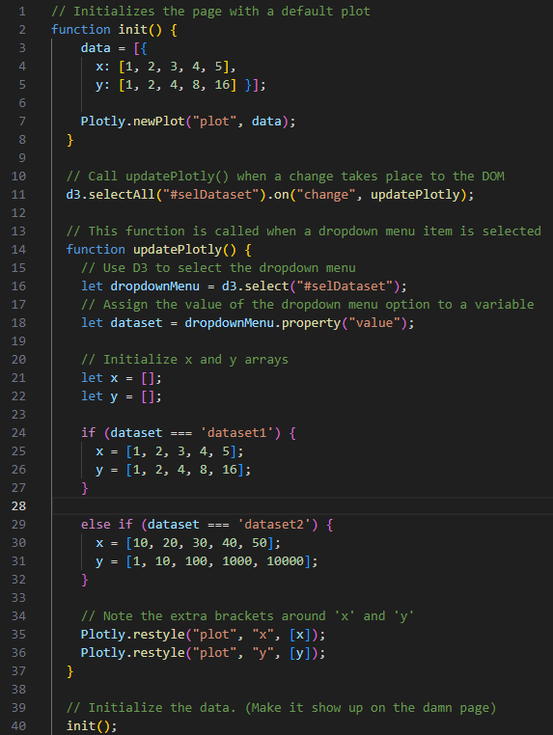

^ If you comment out lines 11-37, it’ll just show the first data (lines 2-8)

^ Lines 35/36-

**Review 9:18-9:20 in the recording about Plotly.restyle.**

Plotly.restyle is more efficient, since it doesn’t require re-loading the whole graph, only the data.

^ Lines 11, 16, 24, 29- selDataset, dataset1, and dataset2 are all defined in the HTML (Screenshot below)

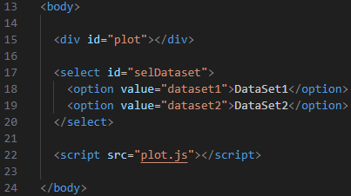

Student Event Final Activity will be covered at start of next class on Thursday 12/21.

It’s pretty long.

